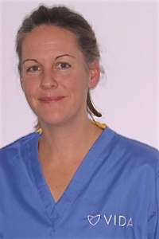

GDC 74566

Helen is our resident Oral Surgeon and Seditionist and undertakes the most complex surgical procedures at VIDA as well as more routine extractions. Additionally, Helen gained a Masters in Implant Dentistry from the University of London in 2007 and is well placed to understand the importance of preserving delicate bone and tissues around your teeth during a dental extraction. This particular skill is in great demand at VIDA where many of our extraction patients are hoping to proceed with implants at a later time, and will require adequate and healthy tissues around the socket to do so. Helen has a young family of two boys with her husband Jon, who works as an A&E Consultant at Worthing Hospital. In her spare time Helen enjoys tennis and training her new puppy, Bodicea.

Current practice

Helen is Associate Specialist in Oral Surgery at East Grinstead Hospital where runs Consultant clinics, treating  adults and children removing teeth and performing sedation and complex surgery of the mouth and teeth.

Recently accredited as Clinical Teacher at the Royal College of Physicians, Helen is also  Educational Supervisor for Dental Nurse Sedation and is responsible for teaching  and mentoring  at various sedation centres throughout the South.

Experience

Children extractions

Adult extractions

Wisdom tooth extractions

All surgical extractions

Grafting and Guided bone regeneration

Apicectomies

Surgical dermatology

Research and publications

Helen’s Masters thesis was titled 'Patient Experience of Dental Implants’ 2007

Educational Supervisor for Dental Nurse Sedation.

Accredited Clinical Teacher at the Royal College of Physicians

Accredited by the Society for Advancement of Anaesthesia in Dentistry Sedation (SAAD)