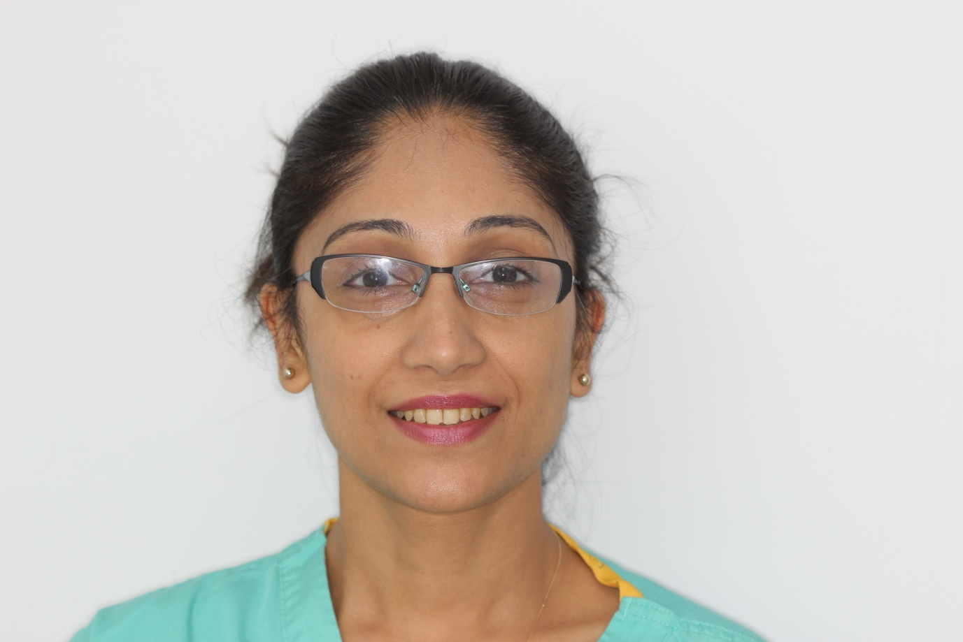

Nidhi is a vastly experienced hygienist who can offer direct access appointments (meaning you don’t need to be registered with one of our dentist) enjoys working with the advanced equipment and dedicated patients at VIDA Dentistry for Life.

Nidhi is a valued member of our team and her usual clinics are on Mondays however Nidhi also works closely with our midweek team to cover periods of absence and provide continuity of care.

Nidhi says “The patients at this practice are very well educated in gum health and are very diligent with their home care. It is always a pleasure to work here and the facilities are exceptional.”

Nidhi has a particular interest in medical conditions affecting gum health and as a mother she knows all too well the value of expert oral hygiene instruction from an early age to keep gums and teeth healthy for life.”

Our patients are full of praise for Nidhi and her gentle touch. We look forward to introducing you to Nidhi and are here to answer any questions you may have.